

**Online shop system**

**Software Requirement Specification**

**Team 1**

– Hanoi, February 2023 –

Record of changeS

|  |  |  |  |
| --- | --- | --- | --- |
| Date | A* M, D | In charge | Change Description |
| 7/2 | A | GiangNXT | Add screen flow( I.2.a) |
| 8/2 | A | GiangNXT | Add introduction (I.1), screen details(I.2.b), User Authorization(I.2.c) |
| 10/2 | M | GiangNXT | Update screen flow (I.2.a), screen details(I.2.b) |
| 15/2 | A | GiangNXT | Add erd (I.3) |
|  |  |  |  |
|  |  |  |  |
|  |  |  |  |
|  |  |  |  |
|  |  |  |  |
|  |  |  |  |
|  |  |  |  |
|  |  |  |  |

*A - Added M - Modified D - Deleted

**Table of Contents**

I. Overview 5

1. Introduction 5

2. System Functions 6

3. Entity Relationship Diagram 9

II. Functional Requirements 10

1. Public Feature 10

a. Home Page 10

b. Products List 10

c. Product Details 11

d. Check the order 11

e. My Cart 11

f. Payment Page 11

g. Cart Completion 11

2. Common Feature 11

a. User Login 11

b. User Authorization 11

c. User Profile 11

d. My Orders 11

e. Order Information 11

# I. Overview

## 1. Introduction

The shopping online system is an e-commerce platform that allows users to purchase products (phone or laptop). The system will be used in a web-based environment and is accessible through a desktop or mobile device with an internet connection. The users of the system are customers who are looking to purchase products.

Constraints for the system include the requirement for accurate product information and inventory management. Assumptions for the system include a stable internet connection and a functional web browser. Dependencies for the system include a database to store customer information and purchase history.

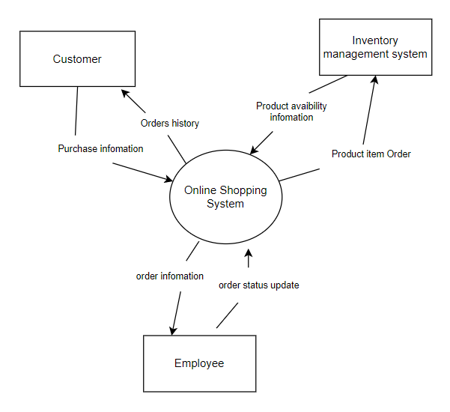

## 2. System Functions

#### a. Screen Flow

#### b. Screen Details

|  |  |  |  |
| --- | --- | --- | --- |
| **#** | **Feature** | **Screen** | **Description** |
| 1 | Public | Home Page | - Show navigation bar: product search box, product categories (phone or laptop), cart - Shown featured products, promotional product, product list (phone and laptop) - Shown product information includes its thumbnail, title, brief information; the user is redirected to the product's details on his/her clicking |
| 2 | Public | Products List | - Show navigation bar: product search box, product categories (phone or laptop), cart  - Show the products paginated (sorted by updated date)  - Shown product information includes its thumbnail, title, brief information, original price, and sale price;  - The user can: sort list by promotional, increasing price, decreasing price and filter product  - The user is redirected to the product's details on his/her clicking on the product |
| 3 | Public | Product Details | - Show navigation bar: product search box, product categories (phone or laptop), cart  - Show product details (including title, category, images, original price, sale price, and detail information) |
| 4 | Public | Check the Order | - Show navigation bar: product search box, product categories (phone or laptop), cart  - The user can search order information by bill of landing code |
| 5 | Public | My Cart | - Show navigation bar: product search box, product categories (phone or laptop), cart  - Show the cart details with list of the user's chosen products (including Id, title, price, quantity, total cost) and the total order price  -The user can:  + Change the quantity of each product: the total cost is automatically adjusted  + Choose to delete/remove product by clicking on the deleting icon  + Click the Remove All to remove all product in cart  + Click the Continue Shopping button to go to Products List page  + Click the Check Out button to go to the Cart Contact page Please notes: the user's chosen products from the last browsing session are remained in his/her cart until s/he submit the cart. However, the product prices are updated with the latest prices in the system |
| 6 | Public | Payment Page | - Show navigation bar: product search box, product categories (phone or laptop), cart  - Show the list of user’s chosen product (including id, title, price, quantity, total cost), the total order price and the receiver information (including full-name, email, mobile, address, notes, payment method) for user to edit/input  - In case the user has logged in, the receiver information would be filled with the user's information  - The user can click the My Cart button to come back to the My Cart page for changing the choosing products, click the Submit button to submit the order before redirecting user to the Card Completion or Error page (due to technical error or any out-of-stock product) |
| 7 | Public | Cart Completion | - Show navigation bar: product search box, product categories (phone or laptop), cart  - Show the cart completion notes. Before this page is shown: - The Order status is changed to submitted;  - The product's available quantities are updated accordingly - The submitted order is assigned automatically to the active sales rotated - If the receiver information (name, email, mobile, gender) is new or changed (checking via the email0, the latest receiver information is stored in the system as latest & historical system contact information. - The customer/user would be received the order confirmation via his/her email. Those information is shown on the page also. |
| 8 | Common | User Login | This screen allows the user to login with email, after login user redirect to Home page |
| 9 | Common | User Profile | This screen allows the user to edit his/her profile information (including full-name, email, mobile, address). |
| 10 | Common | My Orders | - Show navigation bar: product search box, product categories (phone or laptop), cart  - Show the list of user's orders paginated - Each order include below information: id, ordered date, order status, total cost, order information link; - On clicking the order information link, user would be redirected to the Order Information page |
| 11 | Common | Order Information | - Show navigation bar: product search box, product categories (phone or laptop), cart  - Show the order details, including the information as below - The order id, order date, total cost, status - The receiver information: full name, email, mobile - This list of ordered products, each product include following information & the links/buttons that allow the user to re-buy: thumbnail, name, category, unit price, quantity, total cost  For the submitted orders, the user can choose to update (redirect the user to the Cart Details page for that) or cancel the order |

#### c. User Authorization

|  |  |  |  |  |  |
| --- | --- | --- | --- | --- | --- |
| **Screen** | **Guest** | **Customer** | **Sale** | **Warehouse Manager** | **Admin** |
| Home Page | X | X |  |  |  |
| Products List | X | X |  |  |  |
| Product Details | X | X |  |  |  |
| Check the Order | X | X | X | X | X |
| My Cart | X | X |  |  |  |
| Payment Page | X | X |  |  |  |
| Cart Completion | X | X |  |  |  |
| User Login |  | X | X | X | X |
| User Profile |  | X | X | X | X |
| My Orders |  | X |  |  |  |
| Order information |  | X |  |  |  |
|  |  |  |  |  |  |
|  |  |  |  |  |  |
|  |  |  |  |  |  |
|  |  |  |  |  |  |

In which:

* Guest: unregister user
* Customer: customers or potential customers
* Sale: the sale members of the organization
* Warehouse Manager: the warehouse manager in the organization
* Admin: the organization leader/manager, acts as the system administrator

#### d. Non-Screen Functions

|  |  |  |  |
| --- | --- | --- | --- |
| **#** | **Feature** | **System Function** | **Description** |
| 1 | Common | User Authorization | Implementation of authorization mechanism in the system, including the specify the role of logged-in user, his/her authorized page links (building the displayed menu items (in the front end) and preventing unauthorized access via enter the links directly) |
| 2 | … |  |  |

## 3. Entity Relationship Diagram

# II. Functional Requirements

## 1. Public Feature

### a. Home Page

* Function trigger: Direct access via link: “#” or after login by gmail
* Function description:
  + Customer and Guest roles will have access to this screen
  + This screen show navigation bar to navigate to other screens/functions
  + This screen show lists of products
* Screen layout:

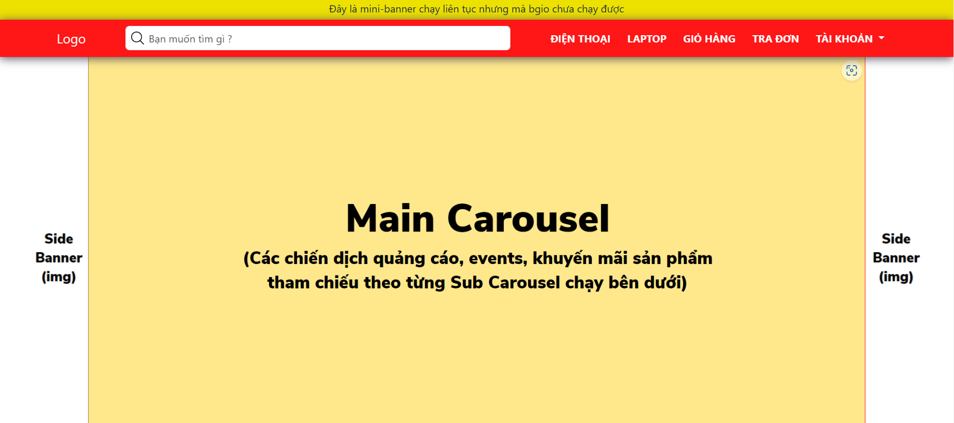

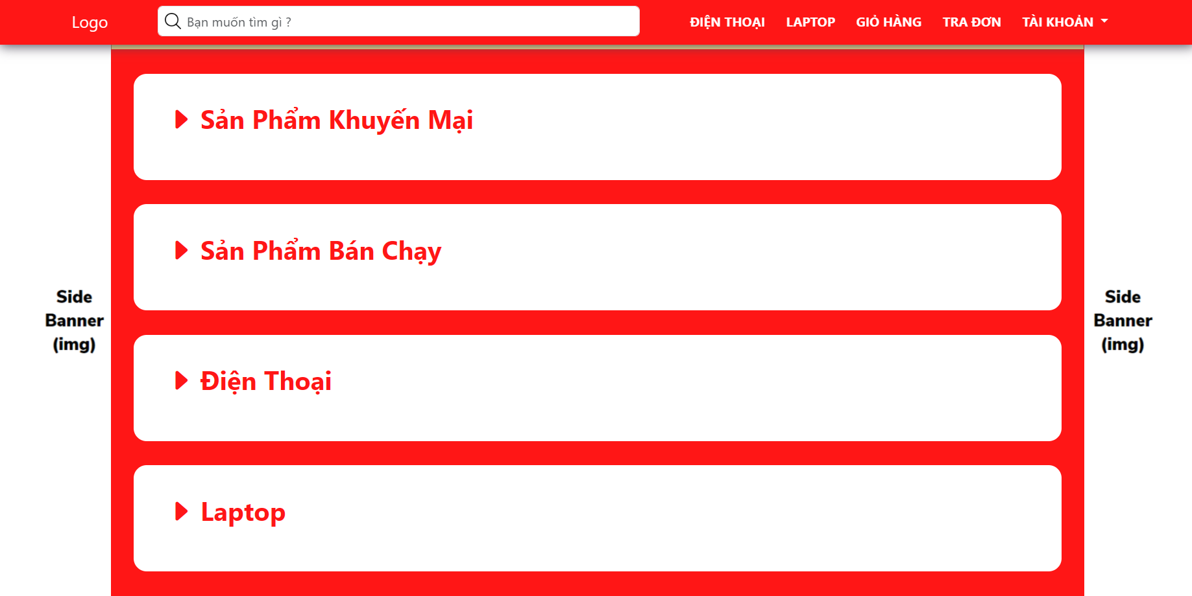

* Function Details:
  + Components to link to the other functions
  + This screen includes navigation bar (product search box, product categories (phone or laptop), cart) and lists of products (featured products, promotional product, phone list, laptop list)

### b. Products List

* Function trigger: When user click on “Phone” or “Laptop” button on navigation bar
* Function description:
  + Customer and Guest will have access to this screen
  + The purpose of this function is to show all available products with the product's category on the website
* Screen layout:

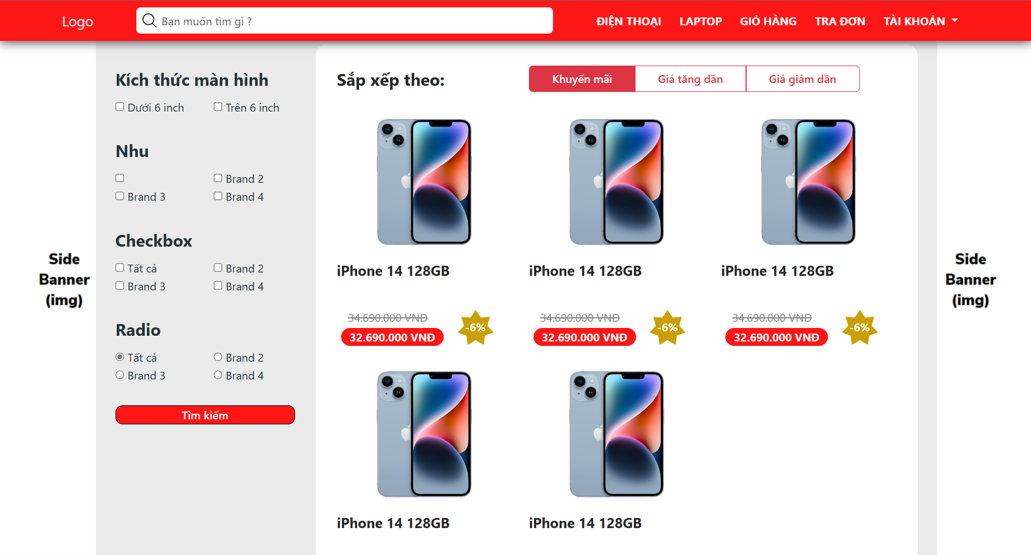

* Function Details:
  + Show all products paginated (sorted by update date)
  + Filter product by each category corresponding to the product
  + Sorting products by price
  + The user is redirected to the product's details on his/her clicking on the product

### c. Product Details

* Function trigger: When user click on the product
* Function description:
  + Customer and Guest will have access to this screen
  + This screen show detail information of specific product
* Screen layout:
* Function Details:
* Show product information with thumbnail, title, brief-info, reviews, product description and “Add to Cart” button.
* *Customers must choose the quantity and add to cart before buying. After clicking the “Add to Cart” button, a popup shows up and customers can choose to continue shopping (the popup disappears) or go to their baskets.

### d. Check the order

* Function trigger:
* Function description:
* Screen layout:
* Function Details:

### e. My Cart

* Function trigger:
* Function description:
* Screen layout:
* Function Details:

### f. Payment Page

* Function trigger:
* Function description:
* Screen layout:
* Function Details:

### g. Cart Completion

* Function trigger:
* Function description:
* Screen layout:
* Function Details:

## 2. Common Feature

### a. User Login

* Function trigger:
* Function description:
* Screen layout:
* Function Details:

### b. User Authorization

* Function trigger:
* Function description:
* Screen layout:
* Function Details:

### c. User Profile

* Function trigger:
* Function description:
* Screen layout:
* Function Details:

### d. My Orders

* Function trigger:
* Function description:
* Screen layout:
* Function Details:

### e. Order Information

* Function trigger:
* Function description:
* Screen layout:
* Function Details: